Djibouti

## Population Data

The data set shows the political stability estimate of the country each year.

## # A tibble: 23 x 5  
## country iso3c date population popCategory5  
## <chr> <chr> <dbl> <dbl> <chr>   
## 1 Djibouti DJI 1996 643654 very small   
## 2 Djibouti DJI 1997 660863 very small   
## 3 Djibouti DJI 1998 680463 very small   
## 4 Djibouti DJI 1999 699975 very small   
## 5 Djibouti DJI 2000 717584 very small   
## 6 Djibouti DJI 2001 733015 very small   
## 7 Djibouti DJI 2002 746942 very small   
## 8 Djibouti DJI 2003 759641 very small   
## 9 Djibouti DJI 2004 771603 very small   
## 10 Djibouti DJI 2005 783254 very small   
## 11 Djibouti DJI 2006 794563 very small   
## 12 Djibouti DJI 2007 805451 very small   
## 13 Djibouti DJI 2008 816358 very small   
## 14 Djibouti DJI 2009 827823 very small   
## 15 Djibouti DJI 2010 840198 very small   
## 16 Djibouti DJI 2011 853674 very small   
## 17 Djibouti DJI 2012 868136 very small   
## 18 Djibouti DJI 2013 883293 very small   
## 19 Djibouti DJI 2014 898696 very small   
## 20 Djibouti DJI 2015 913993 very small   
## 21 Djibouti DJI 2016 929112 very small   
## 22 Djibouti DJI 2017 944097 very small   
## 23 Djibouti DJI 2018 958920 very small

# Population growth data

## # A tibble: 23 x 5  
## country iso3c date popGrowth popGrowthCat5   
## <chr> <chr> <dbl> <dbl> <chr>   
## 1 Djibouti DJI 1996 2.08 moderate growth rate  
## 2 Djibouti DJI 1997 2.64 high growth rate   
## 3 Djibouti DJI 1998 2.92 high growth rate   
## 4 Djibouti DJI 1999 2.83 high growth rate   
## 5 Djibouti DJI 2000 2.48 moderate growth rate  
## 6 Djibouti DJI 2001 2.13 moderate growth rate  
## 7 Djibouti DJI 2002 1.88 moderate growth rate  
## 8 Djibouti DJI 2003 1.69 moderate growth rate  
## 9 Djibouti DJI 2004 1.56 moderate growth rate  
## 10 Djibouti DJI 2005 1.50 slow growth rate   
## 11 Djibouti DJI 2006 1.43 slow growth rate   
## 12 Djibouti DJI 2007 1.36 slow growth rate   
## 13 Djibouti DJI 2008 1.35 slow growth rate   
## 14 Djibouti DJI 2009 1.39 slow growth rate   
## 15 Djibouti DJI 2010 1.48 slow growth rate   
## 16 Djibouti DJI 2011 1.59 moderate growth rate  
## 17 Djibouti DJI 2012 1.68 moderate growth rate  
## 18 Djibouti DJI 2013 1.73 moderate growth rate  
## 19 Djibouti DJI 2014 1.73 moderate growth rate  
## 20 Djibouti DJI 2015 1.69 moderate growth rate  
## 21 Djibouti DJI 2016 1.64 moderate growth rate  
## 22 Djibouti DJI 2017 1.60 moderate growth rate  
## 23 Djibouti DJI 2018 1.56 moderate growth rate

## Population trend

The plot shows the population trend of the country.

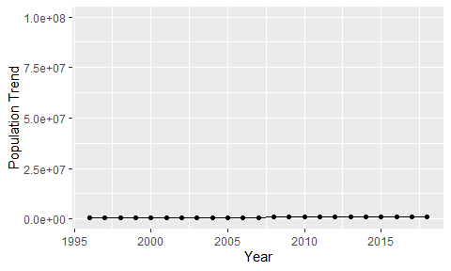

Political Stability Trend

# Population growth trend

The plot shows the population growth rate trend of the country.

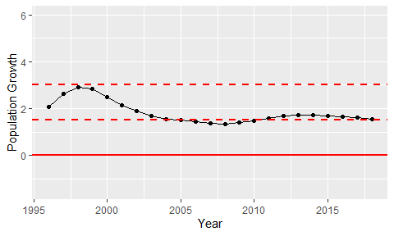

Population Growth Trend